Elizabeth Beauchamp
e.beauchamp2@newcastle.ac.uk

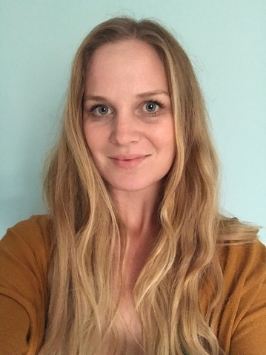
Why did you choose to study with the ONEPlanet DTP? What are you researching?
The program provides cross disciplinary training which is ever more important in order to achieve global goals. My area of research explores the impacts of elevated sea temperatures to coral physiology and whether these traits can be passed on through generations. This research will provide knowledge of how, and to what extent corals can deal with heat stress, as well as, if corals can be selectively bred (human assisted evolution) to increase their heat tolerance to be used for sexual restoration programs.

What do you think are the key benefits of your postgraduate study?
Millions of people globally rely on coral reefs as a food and income source. Corals are facing unprecedented declines due to anthropogenic factors, with increasing sea temperatures their main threat. Through human assisted evolution there is hope to produce corals able to survive higher temperatures, increasing coral reef resilience to sea temperature rise, which has the potential to preserve the important role coral reefs have within economic and ecological systems.

How will your current research/study help you achieve your career ambitions?
PhD research will focus my study in order to become an expert in my chosen field. I hope to continue with research, discovering more about how climate change is impacting ecological systems from a molecular level and finding solutions to prevent negative change at an ecosystem level. Education and advising with legislation/policy is another angle which must be covered to mitigate risks towards human health and livelihoods which I believe PhD study will give me the expertise to be able to contribute to.

What impact will your current research achieve?
The research I am currently involved with is at the forefront of human assisted evolution (HAS) of coral reef research. Knowledge which is gained will be used to inform other HAS projects and to enhance sexual coral restoration practices on a global scale. I believe research is only the start, to have the biggest impact effective communication through; education, public awareness and to policy makers must be done.

What have you enjoyed most about being a student in Newcastle/Northumbria?
The friendliness of everyone in the university, school and Newcastle is wonderful! I have enjoyed the breadth of seminars which have been held as well as having an interdisciplinary research community has broadened my knowledge, as well as strengthened my own research.

Can you recommend three ‘top tips’ (pieces of advice) to share with new students?
- Don’t be afraid to ask questions
- The countryside surrounding Newcastle is wonderful, don’t forget to get out and explore
- Get a bike, great mode of transport and exercise

What is your best memory of your time here so far?
- Walks along the beach in Whitley bay
- Getting accepted for my first international presentation!

Anything else you would like to tell us?
(For example, have you become a student ambassador, gained any work experience, joined any clubs, societies or teams, reached any personal goals, or have any other comments you’d like to make?
Previously, I worked in conservation/ecotourism in Northwest Madagascar for 4 years where I witnessed the importance of coral reefs to local people, some of the many challenges brought about by climate change and how impacts are amplified for economically poorer communities. I hope that through research, better futures can be sought for those most impacted by our changing climate.
Other activities include yoga and much dog walking!

